Double Buffering

Definition:
# Source: AI Source: Provided by: [Data Path: Persons Table -> ID Column: 1, Name_En Column: Motasem Essam] -> From: [Chatgpt (GPT‑5 Mini)] on [1/26/2026]
Double buffering is a technique where two buffers are used alternately—one buffer is used for processing or displaying data, while the other is being filled or written to. This ensures continuous data flow and reduces delays or flickering, especially in graphics, video, or streaming applications.

How It Works
# Source: AI Source: Provided by: [Data Path: Persons Table -> ID Column: 1, Name_En Column: Motasem Essam] -> From: [Chatgpt (GPT‑5 Mini)] on [1/26/2026]
- Two buffers are allocated in memory: Buffer A and Buffer B.
- While the program or device is using data from Buffer A, new data is loaded into Buffer B.
- Once Buffer A is finished, the roles of the buffers are switched:
  - Buffer B is used for processing/output
  - Buffer A is refilled with new data
- This cycle continues, allowing smooth and uninterrupted operation.

Advantages of Double Buffering
# Source: AI Source: Provided by: [Data Path: Persons Table -> ID Column: 1, Name_En Column: Motasem Essam] -> From: [Chatgpt (GPT‑5 Mini)] on [1/26/2026]
- Eliminates delays or flickering in graphics displays.
- Smooths data flow between fast and slow devices.
- Improves performance in real-time systems.
- Allows simultaneous processing and data transfer.

Example
# Source: AI Source: Provided by: [Data Path: Persons Table -> ID Column: 1, Name_En Column: Motasem Essam] -> From: [Chatgpt (GPT‑5 Mini)] on [1/26/2026]
- Video playback:
  - Frame 1 is displayed from Buffer A
  - Next frame is loaded into Buffer B
  - Frames alternate between the two buffers → smooth playback
- Graphics rendering:
  - Screen displays content from one buffer
  - Program draws the next frame in the other buffer
  - Switch buffers → no flicker

Analogy
# Source: AI Source: Provided by: [Data Path: Persons Table -> ID Column: 1, Name_En Column: Motasem Essam] -> From: [Chatgpt (GPT‑5 Mini)] on [1/26/2026]
- Single buffer: Chef cooks a dish → serves immediately → waits for cooking next dish
- Double buffer: Chef cooks in one pot while the other pot is being served → continuous flow of meals, no delay

✅ Summary of Buffering Types
# Source: AI Source: Provided by: [Data Path: Persons Table -> ID Column: 1, Name_En Column: Motasem Essam] -> From: [Chatgpt (GPT‑5 Mini)] on [1/26/2026]
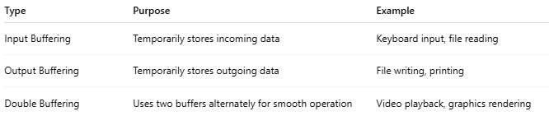
Type | Purpose | Example
Input Buffering | Temporarily stores incoming data | Keyboard input, file reading
Output Buffering | Temporarily stores outgoing data | File writing, printing
Double Buffering | Uses two buffers alternately for smooth operation | Video playback, graphics rendering

